Übung Subnetting

Berechne Subnetz für 192.168.85.170/24: CIDR: Classless Inter Domain Routing

VLSM: Variable Length Subnet Mask

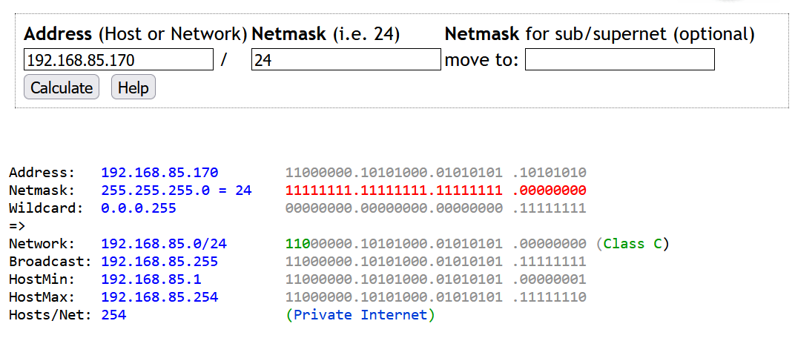

Berechne Subnetz für 192.168.85.170/25:

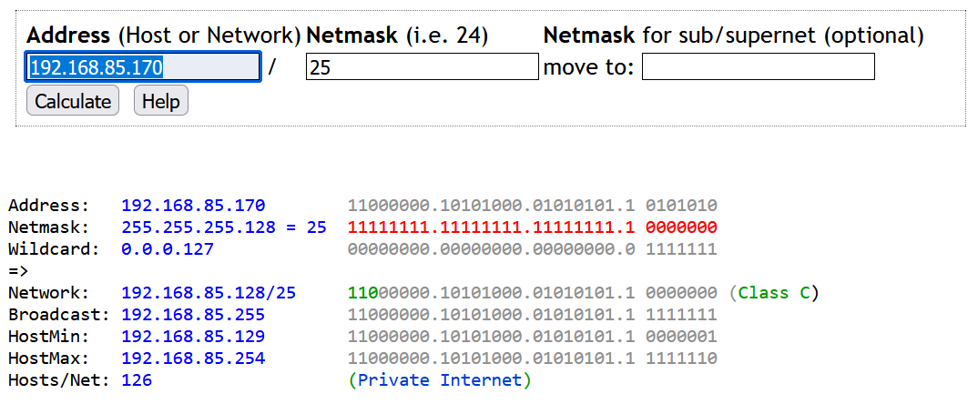

Berechne Subnetz für 192.168.85.170/26:

|  |  |  |
| --- | --- | --- |
| Address | 192.168.85.170 | 1100 0000. 1010 1000. 0101 0101. 1010 1010 |
| Netmask | 255.255.255. | 1111 1111. 1111 1111. 1111 1111. 1100 0000 |
| Wildcard | 0.0.0. | 0000 0000. 0000 0000. 0000 0000. 0011 1111 |
| Network |  |  |
| Broadcast |  |  |
| HostMin |  |  |
| HostMax |  |  |
| Anzahl Hosts |  |  |

Berechne Subnetz für 192.168.85.170/27:

|  |  |  |
| --- | --- | --- |
| Address | 192.168.85.170 | 1100 0000. 1010 1000. 0101 0101. 1010 1010 |
| Netmask | 255.255.255. |  |
| Wildcard | 0.0.0. |  |
| Network |  |  |
| Broadcast |  |  |
| HostMin |  |  |
| HostMax |  |  |
| Anzahl Hosts |  |  |